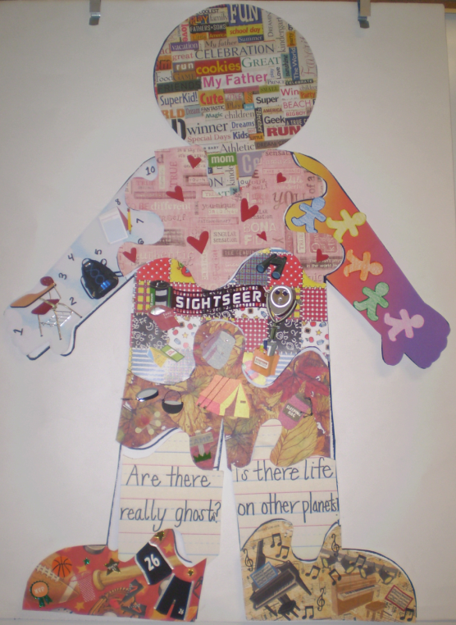

*Figure 7.* Mixed media collage was used by this student in her aesthetic representation.

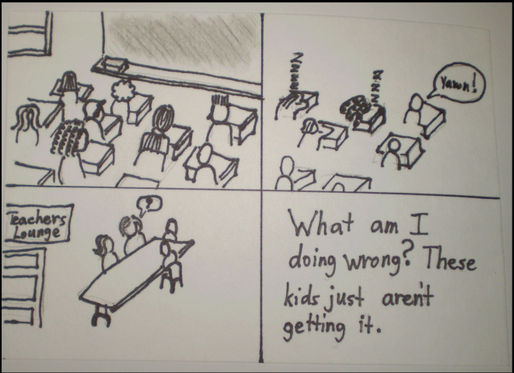

*Figure 8*. A student used writing within the context of a comic book to demonstrate her understanding of differentiation.

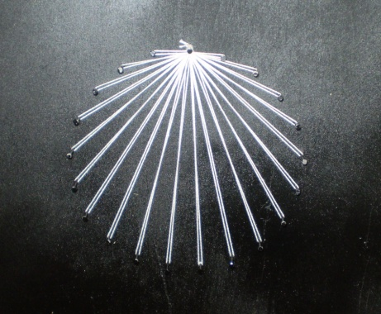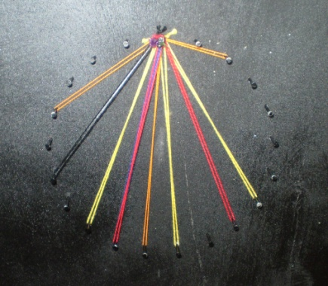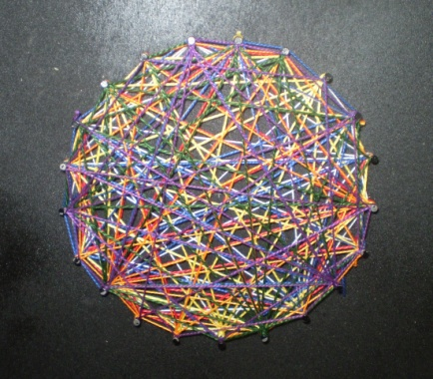

*Figure 9:*

Student’s own experience Student’s son’s experience Student’s future classroom