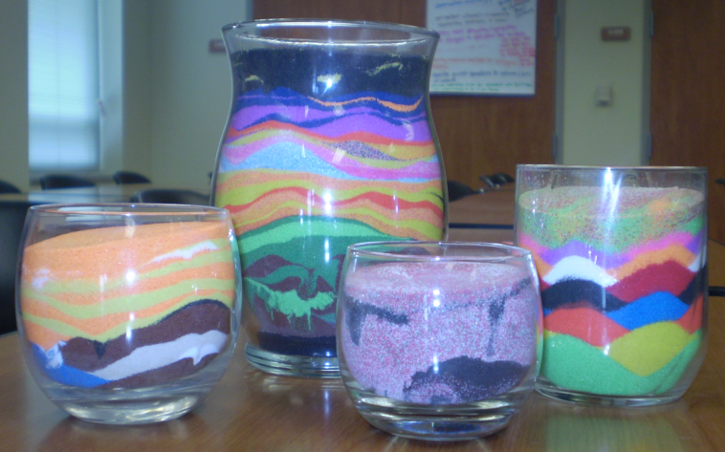

*Figure 5*. A student created various sand art designs for her aesthetic representation.

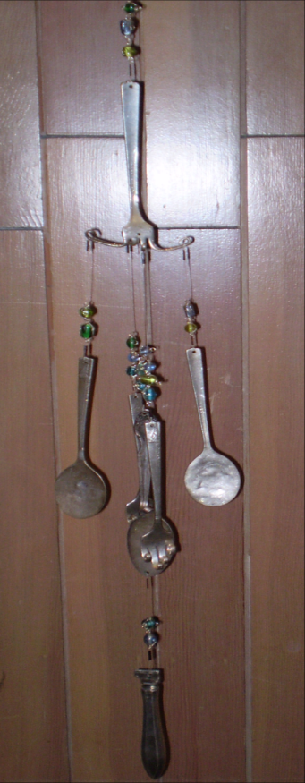

*Figure 6*. Specific elements related to family interactions are used to create components of a wind chime.