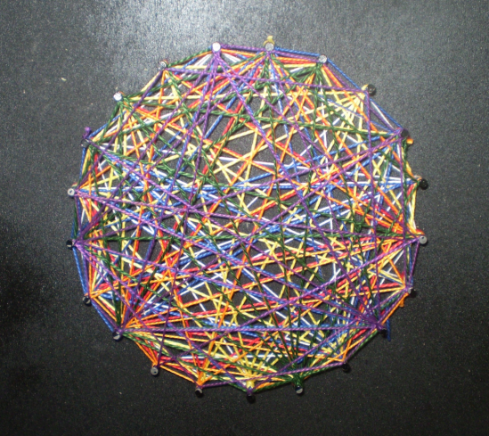

*Figure 1*. Mathematics inspired string art represented one student’s understanding of differentiation.

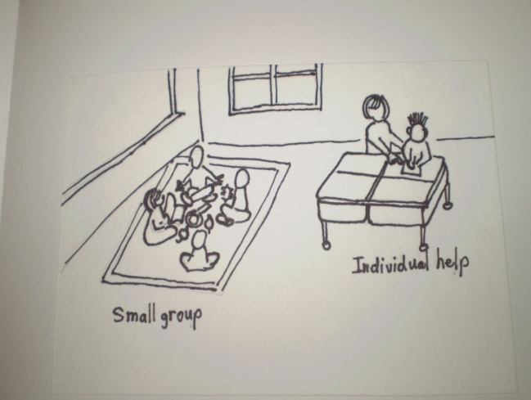

*Figure 2*. Through writing and drawing, this student demonstrated understanding with a comic book.